

**Data Technician**

|  |
| --- |
|  |

|  |
| --- |
| Name: Thandeka Mukazi |
| Course Date: 9th June – 13th June 2025 |
|  |

**Table of contents**

Day 1: Task 1 3

Day 1: Task 2 3

Day 1: Task 3 4

Day 2: Task 1 5

Day 3: Task 1 9

Day 3: Task 2 10

Day 3: Task 3 11

Day 4: Task 1 12

Day 4: Task 2 13

1. Scenario Background 13

2. Data Laws and Regulations 14

3. Azure Service Recommendations 14

4. Data Types and Data Modelling 14

5. Data Storage Formats and Structures in Azure 14

6. Additional Considerations 15

Submission Guidelines: 15

Course Notes 17

Additional Information 17

Google

Microsoft

Amazon – 3 or 4 features

# Day 1: Task 1

Please research and complete the below questions relating to key concepts of cloud.

Be prepared to discuss the below in the group following this task.

|  |  |
| --- | --- |
| What can cloud computing do for us in the real-world? | One example of what cloud computing can do for us in the real world is through streaming platforms such as Netflix:  The Role of Cloud Computing in Netflix:   * Content delivery at scale = The cloud allows Netflix to quickly scale its servers and bandwidth to meet demand without crashing (e.g. many people clicking ‘play’ at once. * Global Availability = The cloud stores and distributes content from data centres globally so users all over the world can all get smooth, localised streaming experiences * Speed and Personalisation = Netflix uses cloud based AI which analyses watch history in real time and can recommend shows you’re likely to enjoy watching. * Updates Without Downtime = Netflix can roll out new features across their platform using cloud deployment tools without interrupting services.   What this means for users:   * Convenience = Flexibility to watch content from any device. Anytime, anywhere. * Speed and Realisability = Less worries related to waiting for downloads or worrying about buffering. * Personal Experience = Algorithms are geared towards your personal tastes and interests. |
| How can it benefit a business? | In the Netflix example, cloud computing can benefit them as a business in 3 ways:  Cost Efficiency = Instead of having to buy and maintain physical servers, Netflix only pays for the cloud resources it uses. This reduces infrastructure costs and means they can invest in other things such as new features.  Faster Innovation = Allows Netflix to quickly test and roll out new features without major delays. This keeps the platform fresh and ahead of their competitors.  Scalability = Allows Netflix to stream to millions of users simultaneously without slowing down or crashing. This supports subscriber growth worldwide. |
| What’s the alternative to cloud computing? | The main alternative to cloud computing is on-premises infrastructure. The company owns and manages its own physical servers and data centres. All data storage, processing and maintenance are done in house.  Key Differences   * More control but higher upfront costs * Slower to scale and update * Requires a dedicated IT team for maintenance and security |
| What cloud providers can we use, what are their features and functions? | |  |  |  |  | | --- | --- | --- | --- | | Features | AWS | Google Cloud | Microsoft Azure | | Compute Service | EC2 | Compute Engine | Azure Virtual Machines | | Storage | S3 (Simple Storage Service) | Cloud Storage | Azure Blob Storage | | Serverless Computing | Lambda | Cloud Functions | Azure Functions | | Database | RDS (relational) | Cloud SQL | Azure SQL Database | | AI/ML Tools | SageMaker | Vertex AI | Azure Machine Learning | | Best For | Broad service range and scalability | Data Analytics and AI | Enterprise integration with Microsoft | |

# Day 1: Task 2

Please research the below cloud offerings, explain what they are and examples of use cases.

|  |  |  |
| --- | --- | --- |
| Cloud Offerings | Explain what it is | When / how might you use this service in the real-world? |
| IaaS (Infrastructure as a service) | Provides virtualised computing resources over the internet such as servers, storage and networking.  The software is managed by you and the hardware is managed by the provider. | When/How it is used:   * When companies want full control over their applications and data without having to manage physical hardware.   Real World Example: Netflix and Amazon Web Servies (AWS)   * Netflix manages the software and content. * AWS provides the underlying infrastructure such as servers and networking. |
| PaaS (Platform as a service) | Offers a platform with tools and services for building, testing and deploying applications.  This is without managing servers or operating systems. | When/How it is used:   * Used by developers who want to focus on coding and deploying apps quickly – not managing infrastructure.   Real World Example: Spotify and Google App Engine (GCP)   * Developers focus on writing and deploying code. * Google manages the infrastructure behind the scenes. |
| SaaS (Software as a service) | Delivers ready to use software over the internet.  Nothing is installed – they just log in and it is ready to use. | When/How is it used:   * Used by individuals or businesses to access software for elements such as productivity and communication.   Real World Example: Google Workspace   * Includes Gmail and Google Docs for example. * Businesses and individuals can access these tools via a browser – no installation or maintenance needed. |

# Day 1: Task 3

Please research the below terms and explain what they are, when they would be appropriate and a real-world example of where it could be implemented (i.e. what type of organisation).

|  |  |
| --- | --- |
| Public Cloud | What is it?   * A cloud service which is provided over the internet by third party providers (e.g. Azure, Google Cloud) * Resources are shared with other organisations   When it would be appropriate:   * For general computing needs * Where cost-effectiveness and scalability are priorities * When data sensitivity is low   Real World Example of Implementation:   * Ecommerce platforms such as Deliveroo * They use public cloud to quickly scale during high demand without investing in hardware |
| Private Cloud | What is it?   * A cloud environment that is used exclusively by one organisation * It can be hosted on premises or by a third party provider * Offers more control and security   When it would be appropriate:   * For organisations that need high security or regulatory compliance * When performance and control are essential   Real World Example of Implementation:   * Hospitals or banks (e.g. the NHS or Barclays) * They use private cloud to store sensitive patient or financial data securely |
| Hybrid Cloud | What is it?   * This is a combination of public and private clouds working together * Allows moving workloads between environments based on needs   When it would be appropriate:   * When some data must be kept private, but other services can be public * For balancing cost, control and flexibility   Real World Example of Implementation:   * Government agencies or large universities * They may want to keep student/staff records on a private cloud but run public-facing websites on a public cloud |
| Community Cloud | What is it?   * A cloud infrastructure shared by multiple organisations with common goals or compliance requirements * Often used in specific sectors   When would it be appropriate:   * For groups with shared needs * When joint infrastructure is more effective   Real World Example of Implementation   * Universities or research institutions * Some may collaborate on shared projects and use a community cloud to store and share data securely |

# Day 2: Task 1

Describe, with examples, the **three** major areas that the Computer Misuse Act deals with.

|  |  |  |
| --- | --- | --- |
| Area | Description | Example |
| Section 1: Unauthorised Access To Computer Material | Gaining access to computer systems or data without permission. | Student and Teacher Example:   * A student guesses a teacher’s username and password to view exam questions in advance * Often called hacking |
| Section 2: Unauthorised Access With Intent To Commit Or Facilitate A Crime | Building on Section 1 but also adds intent to commit further offences such as theft or fraud. | Online Banking System Example:   * A person hacks into an online banking system so that they can steal money or commit fraud * More serious because access is paired up with criminal intent – beyond just looking at information |
| Section 3: Unauthorised Modification Of Computer Material | Refers to deliberate changes to data or software without permission, often to cause harm or disruption. | Employee Virus Example:   * An unsatisfied employee installs a virus on a company’s system to corrupt files * Includes spreading malware, deleting files or any action that would impair computer operation |

The computer misuse act 1990 is an act where an individual can be criminalised because of computer related offense. Describe three extra powers that the Police and Justice Act 2006 (Computer Misuse) has added.

|  |
| --- |
| Description |
| Increased Penalties for Hacking (Section 35)   * The maximum sentence you can get for unauthorised access was raised * This was raised from 6 months to 2 years * This is to reflect the growing seriousness and impact of cyber related intrusions * Example: Hacking into a social media account could mean facing up to 2 years imprisonment rather than 6 months |
| Addition of Denial of Service Attacks (Section 36)   * It made it a criminal offence to carry out DoS attacks – actions that overload or crash a system/network * A penalty of up to 10 years imprisonment could be given * Example: Flooding a government portal to make it crash and ultimately disrupt services |
| Making Tools For Offences A Crime (Section 37)   * It became illegal to make, supply or obtain tools (e.g. hacking software) intended for computer misuse * A penalty of 2 years imprisonment can be given * Example: Creating and selling password cracking software, knowing that it will be used to commit cybercrime |

Look at the below website to answer the questions:

<https://www.gov.uk/personal-data-my-employer-can-keep-about-me>

|  |
| --- |
| Write down three items of data which a company can store about an employee. |
| * Education and Qualifications |
| * National Insurance |
| * Date of Birth |

|  |
| --- |
| Give three more examples of data that an employer can only store if they first get the employee’s permission. |
| * Sexual History or Orientation |
| * Religion |
| * Health and Medical Conditions |

Conduct further research to answer the below questions.

|  |  |
| --- | --- |
| Question | Answer |
| Provide one example of: Copyright infringement | Downloading + Sharing A Movie   * Downloading and sharing a movie through a torrent site without the permission of the copyright holder * This violates the creator’s legal right to control how their work is copied and distributed |
| Provide one example of: Plagiarism | University Essay   * Copying a paragraph from a website or book into a university essay without citing sources and presenting it as all your own work * This is misleading as others will be lead to believe that you wrote the content yourself |
| What are two consequences of copyright infringement and software piracy? | Legal Consequences   * Individuals or organisations may face fines or legal action * This includes being sued for damages or criminal charges * Example: A person using pirated software could be fined heftily or prosecuted under copyright laws   Security Risks   * Pirated or illegally shared software may contain malware, leading to data loss, hacking or even identity theft * Example: Downloading a cracked software could infect a computer with ransomware |
| Give three possible consequences for individuals when using pirated software | Legal Consequences   * It can lead to fines or prosecution for copyright   Malware and Security Risks   * Personal data could be stolen or your computer being locked until a ransom is paid   Lack of Updates  Doesn’t receive official updates or technical support  Means that you could miss critical security patches which makes your system vulnerable overtime |

Listed below are some laws which we have covered today:

1. Computer Misuse Act 1990

2. Police and Justice Act 2006 (Computer Misuse)

3. Copyright, Designs and Patents Act 1988

4. Copyright (Computer Programs) Regulations 1992

5. The Health and Safety (Display Screen Equipment) Regulations 1992

6. Data Protection Act 2018

7. Consumer Rights Act 2015

* Insert a number in the first column of each row to match each of the statements with one of the above Acts.
* One of statements is incorrect and not illegal. For this statement, write ‘Not illegal’.

|  |  |
| --- | --- |
| **Act number** | **Clause** |
| 4 | With some exceptions, it is illegal to use unlicensed software |
| 7 | Any product, digital or otherwise, must be fit for the purpose it is supplied for |
| 1 | Unauthorised modification of computer material is illegal |
| 2 | It is illegal to create or use a hacking tool for penetration testing |
| 6 | Personal data may only be used for specified, explicit purposes |
| 5 | Employers must provide their computer users with adequate health and safety training for any workstation they work at |
| 2 | It is illegal to distribute hacking tools for criminal purposes |
| 3 | It is illegal to distribute an illicit recording |
| 6 | Personal data may not be kept longer than necessary |
| 1 | Gaining unauthorised access to a computer system is illegal |
| 5 | Employers must ensure that employees take regular and adequate breaks from looking at their screens |
| 2 | It is illegal to prevent or hinder access (e.g. by a denial-of-service attack) to any program or data held in any computer |
| 6 | Personal data must be accurate and where necessary kept up to date |

# Day 3: Task 1

Please complete the below lab (3) *‘Explore relational data in Azure’* and paste evidence of the completed lab in the box provided.

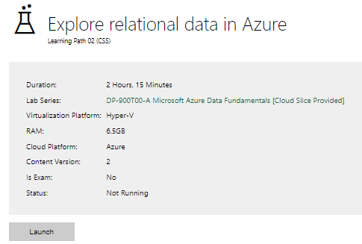

|  |  |
| --- | --- |
| Completed lab |  |

# Day 3: Task 2

Please complete the below lab (4) *‘Explore non-relational data in Azure’* and paste evidence of the completed lab in the box provided.

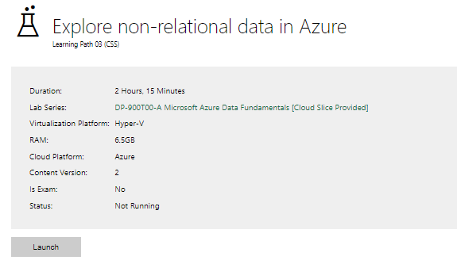

|  |  |
| --- | --- |
| Completed lab |  |

# Day 3: Task 3

Please complete the below lab (5) ‘Explore data analytics in Azure’ and paste evidence of the completed lab in the box provided.

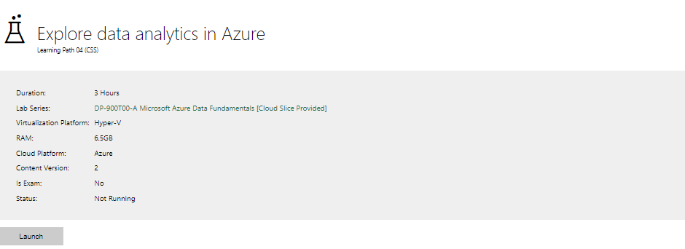

|  |  |
| --- | --- |
| Completed lab | Task 3 – Part 1 (SQL query and graph)      I attempted to delete the workspace but it did not give me an option to. Something it being a trial space and JustIT having the authority to make changes like that to the account.  Task 3 – Part 2 (2 queries)      I attempted to delete the workspace but it did not give me an option to. Something it being a trial space and JustIT having the authority to make changes like that to the account.  Task 3 – Part 3 (for the main categories and the distribution for 1 product and everything including the map + pie chart) |

# Day 4: Task 1

In your teams, complete the Azure DP-900 practice exam and paste your result below – this is open book and please research and discuss your answers as a team.

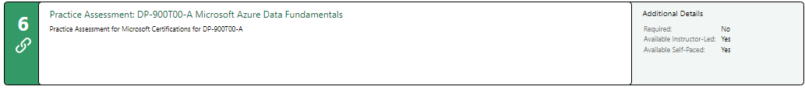

|  |  |
| --- | --- |
| Result | Note: I treated it as a closed book assessment rather than an open book one. |

# Day 4: Task 2

#### **1. Scenario Background**

"Paws & Whiskers" is a growing pet shop that aims to improve its business by analysing sales, customer information, and inventory data. Currently, the data is collected manually or stored in spreadsheets. Management is interested in transitioning to Microsoft Azure to streamline data storage, analysis, and reporting, enabling them to make data-driven decisions.

#### **2. Data Laws and Regulations**

Identify and explain the data laws and regulations relevant to handling customer data within the proposal. Ensure you cover the following points:

* **GDPR Compliance**: Highlight the importance of adhering to the General Data Protection Regulation (GDPR), particularly as it relates to storing and processing customer information.
* **Data Protection Act (DPA) 2018**: Outline how the DPA 2018 may affect the way "Paws & Whiskers" collects and stores data, ensuring compliance with UK laws on data privacy.
* **Other Industry Standards**: Research any additional data protection standards or regulations that may apply to pet shop data, particularly if they involve sensitive or payment information.

#### **3. Azure Service Recommendations**

Recommend Microsoft Azure services that would suit the company’s data analysis needs and explain why these services are suitable. Your recommendations should include:

* **Data Storage**: Identify suitable storage options, such as **Azure Blob Storage** or **Azure SQL Database**, and discuss the benefits of each for storing large datasets, including inventory, sales transactions, and customer details.
* **Data Analysis Tools**: Recommend tools such as **Azure Machine Learning** for customer behaviour analysis or **Azure Synapse Analytics** for analysing sales trends. (could add Fabric – data Lakehouse too).
* **Data Integration and Automation**: Explain how services like **Azure Data Factory** could automate data collection and integration processes, improving efficiency.

#### **4. Data Types and Data Modelling**

Define the types of data "Paws & Whiskers" will need to work with and describe your approach to data modelling:

* **Data Categories**: Identify key data types, such as customer demographics, transaction history, pet inventory, and product categories.
* **Data Modelling Approach**: Outline how you would structure this data using a relational model or a data warehouse approach, considering factors like tables, entities, relationships, and primary keys.

#### **5. Data Storage Formats and Structures in Azure**

Discuss how you would store data within Azure and the formats you would recommend:

* **Data Formats**: Specify recommended formats (e.g., CSV for raw data imports, JSON for structured data, Parquet for analytics) and explain why these formats are suitable for specific data types.
* **Data Security and Encryption**: Include recommendations for securing data using Azure’s built-in encryption features and access controls to ensure compliance with data privacy regulations.

#### **6. Additional Considerations**

Provide any other considerations that might enhance data handling and efficiency in Azure, such as:

* **Backup and Disaster Recovery**: Outline a backup plan using **Azure Backup** or **Azure Site Recovery** to safeguard against data loss.
* **Data Visualisation**: Discuss potential use of **Power BI** within Azure for creating dashboards that provide management with real-time insights into sales and customer trends.
* **Future Scalability**: Comment on how Azure services can scale as the business grows, accommodating larger datasets and more complex analyses.

### **Submission Guidelines:**

1. **Structure**: Ensure your report is well-organised, with sections for each task (e.g., Data Laws, Azure Services, Data Types, etc.).
2. **Formatting**: Include headings, bullet points where appropriate, and any visuals or diagrams that support your explanations.
3. **References**: Cite any resources or regulations referenced in the report.
4. **Length**: Aim for 1500-2000 words.

|  |
| --- |
|  |

|  |
| --- |
| **Course Notes** |

It is recommended to take notes from the course, use the space below to do so, or use the revision guide shared with the class:

<https://learn.microsoft.com/en-us/credentials/certifications/azure-data-fundamentals/?practice-assessment-type=certification>

<https://events.microsoft.com/en-us/>

<https://www.youtube.com/watch?v=XZmGGAbHqa0>

<https://learn.microsoft.com/en-us/shows/on-demand-instructor-led-training-series/?levels=beginner&roles=data-engineer>

<https://app.diagrams.net/>

|  |
| --- |
| **Additional Information** |

We have included a range of additional links to further resources and information that you may find useful, these can be found within your revision guide.

**END OF WORKBOOK**

**Please check through your work thoroughly before submitting and update the table of contents if required.**

**Please send your completed work booklet to your trainer.**